Send an email when a New item Created in SharePoint

You can create a flow that automatically performs one or more actions after it's triggered by an event.

Prerequisites
- An account on flow.microsoft.com
- A Twitter account
- Microsoft Office 365

Specify an event to start the flow
First, you must select the trigger (event) that starts the flow.
- Sign in to Power Automate by using your organizational account.
- Select My flows.
- Select New, and then select Automated cloud flow.
- Under Choose your flow's trigger, enter SharePoint, select the When an Item created trigger and select Create.
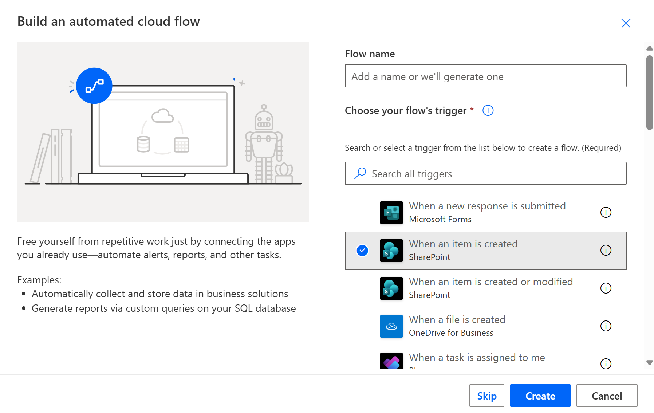
- If you haven't already connected your SharePoint account to Power Automate, select Sign in to SharePoint, and then enter your credentials.
- In the Site Address box, enter/select the SharePoint site URL and select List Name
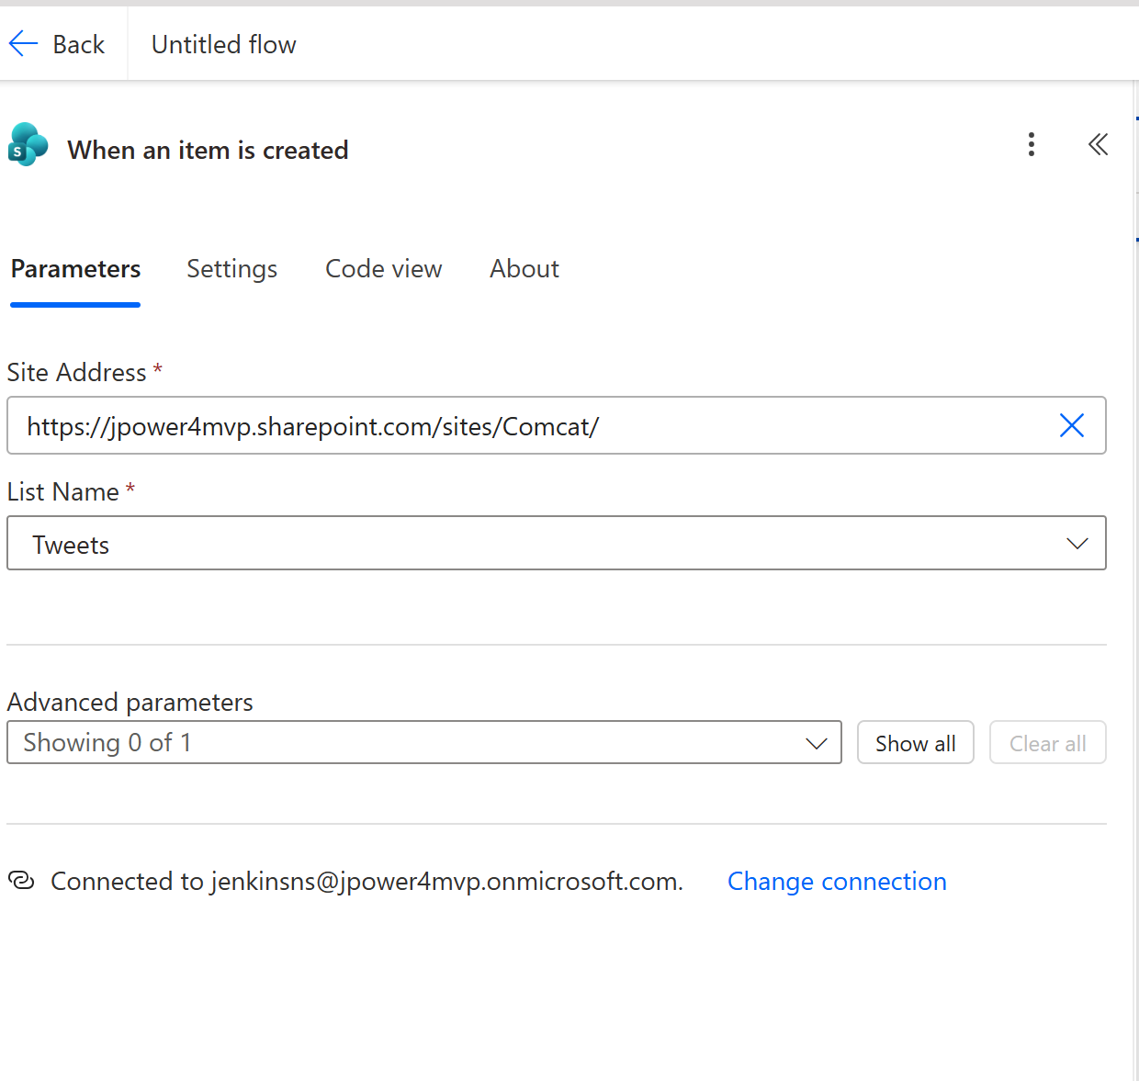

Specify an action
- Select New step, and in the search field, enter send email, and then select the Office 365 Outlook - Send an email (V2) action.
- If you're prompted to sign in, select the sign-in button, and then enter your credentials.
- In the To field, enter or paste your email address, and then select your name in the list of contacts that appears.
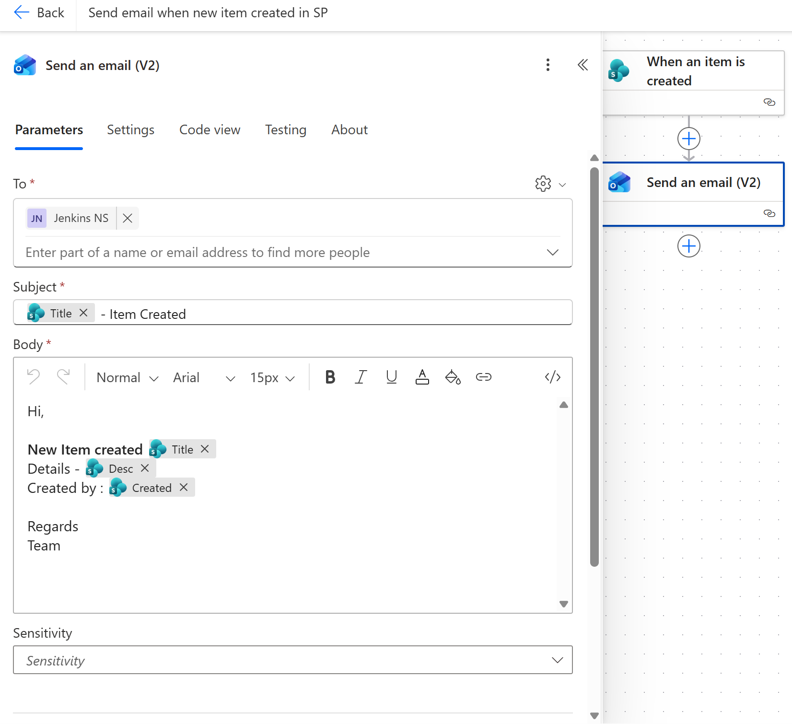
- In the Subject field, add dynamic content Tile and enter -Item Created.
- Add body content as per your requirement.
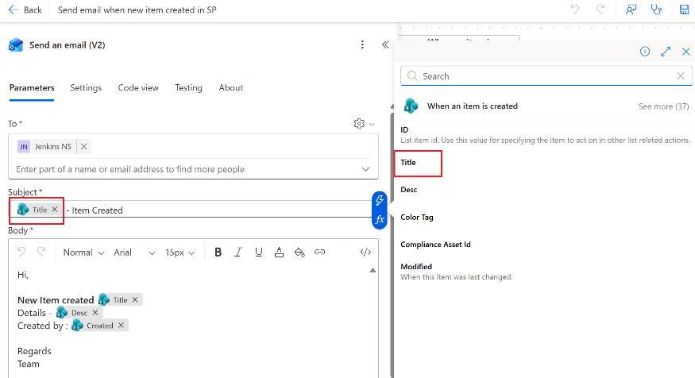
- Optional: Add content, or both to the body of the email.
- Select Save to save the flow.
- Create new item in SharePoint it trigger automatically and send email
Within a 30 seconds after the new item created , an email message will notify you of the new item.

